PROOF OF CONCEPT
XSS (REFLECTED, STORED & DOM)
Tanmay Aherkar
In today’s we will learn how to hack XSS (Reflected, Stored & DOM) while using DVWA & BWAPP as our helper
So, Let’s Begin

- DVWA (REFLECTED)
Login to DVWA application and go to Reflected Cross Site Scripting (XSS) challenge. Provide any input and notice that provided input reflected in the same page.
<script>alert(1)</script>
Payload executed successfully and pop-up is generated.

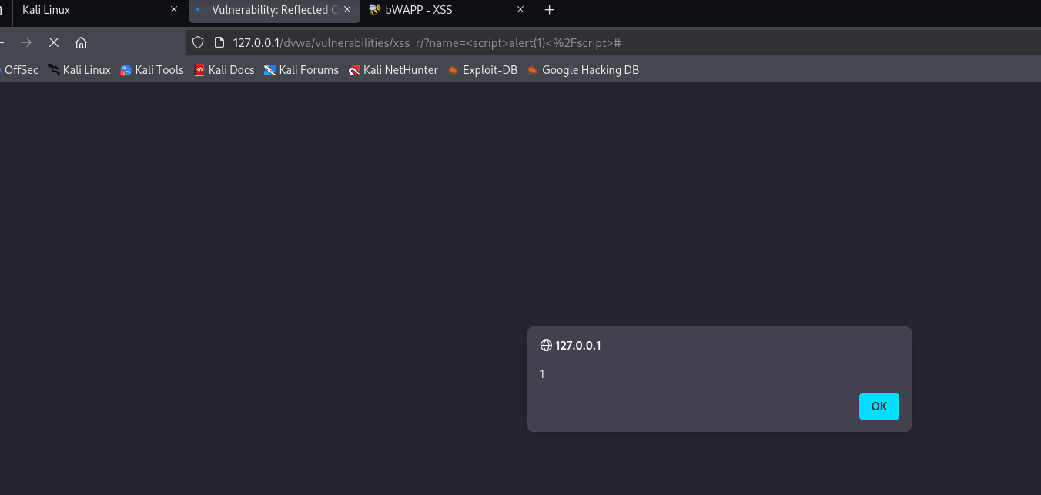

- DVWA (STORED)
Provide inputs for Name and Message fields and click on the Sign Guestbook button. The given value is stored and will display if user visits this page
<script>alert(1)</script>
While we travel to another files the alert(1) is still stored because it is stored in the database of the file.
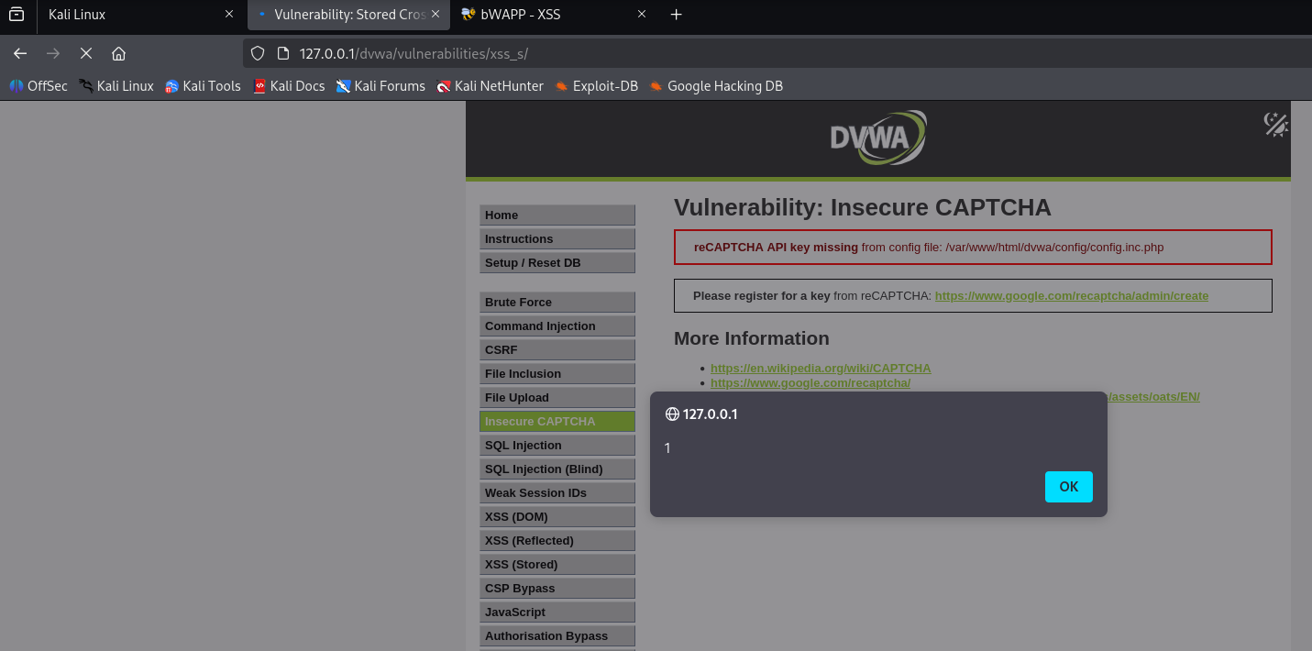

While you can see that I am in Insecure CAPTCHA,I have just clicked on XSS(Stored) then the alert is still shows

- DVWA (DOM)
In DOM-based XSS, the vulnerability is caused by the client-side JavaScript code, which uses unsafe values from the URL or other DOM elements. In this case, vulnerable script reads input directly from the URL’s query parameter and inserts it into the DOM without proper sanitization.

We can see that the it is saying to change the language, where we selected English and in above url we will submit our alert
<script>alert(1)</script>
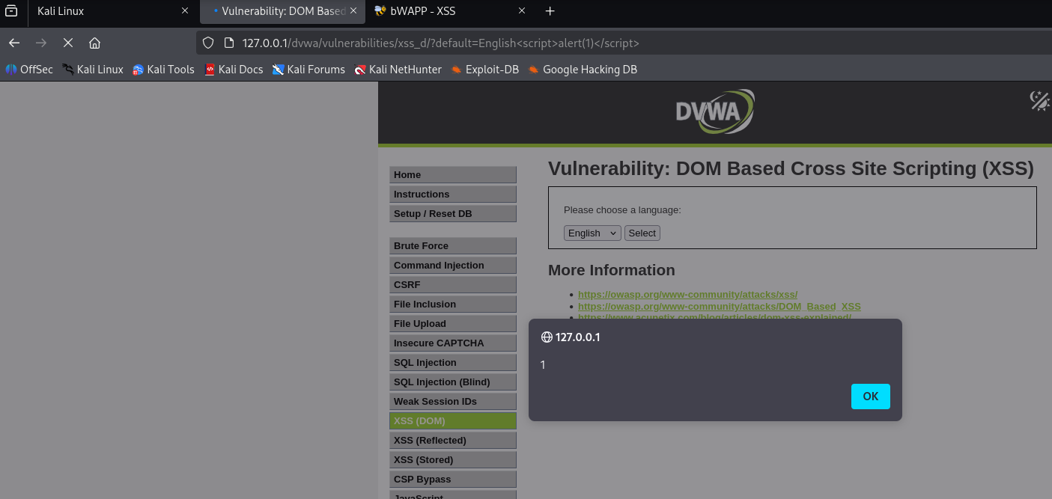

- BWAPP(REFLECTED)
We can see that there are two tabs where we have to fill parameters, but where we will generated our alert
<script>alert(1)</script>
#OUTPUT#
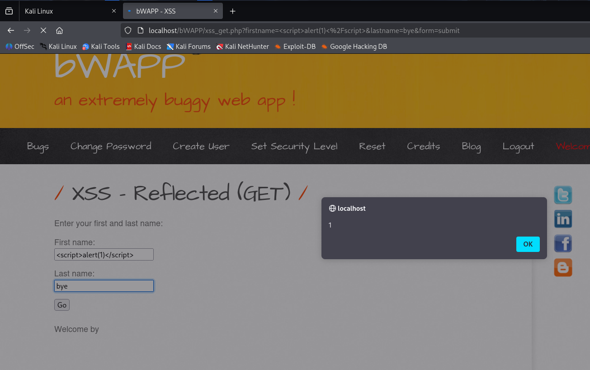

- BWAPP(STORED)
We can see that there is a blog post where we can enter parameters
It is the stored one so if we move or go to another page & then comeback the same alert will show
i.e <script>alert(1)</script>
#OUTPUT#
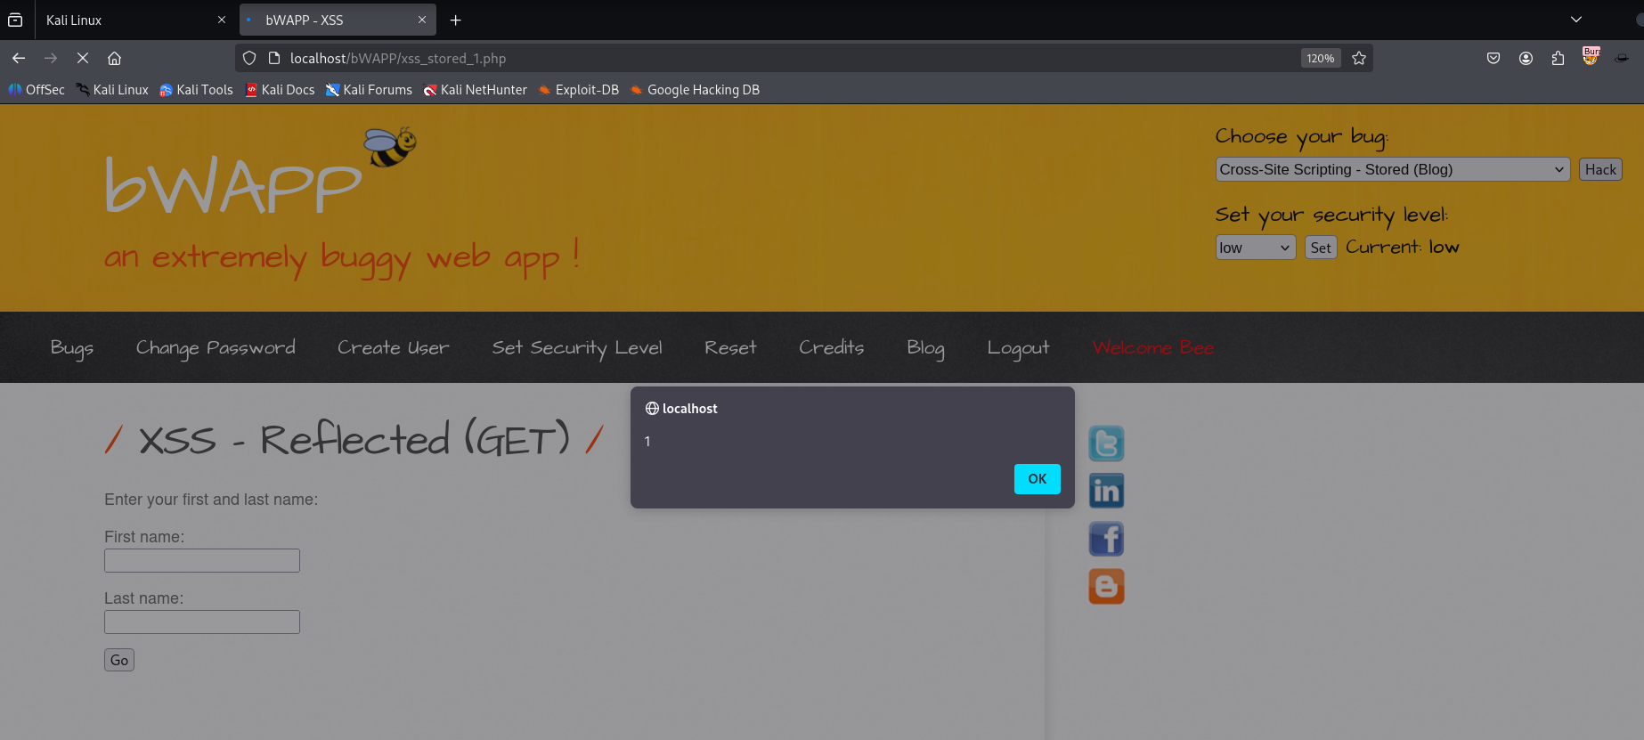
As we can see alert is generated when I selected XSS-Stored Blog
(On the right side corner)

